NEWSLETTER September 2022

Research Committee

**Updates**

**Arc PGC Student and Supervisor Awards Nominations Close**

Thank you for the **235 nominations** made for the Research Candidate, Supervisor and Professional Staff Awards. The Assessment team is now scoring the nominations and we look forward to announcing the Awards on the 1st of November 2022. Further details on the Awards Ceremony will be available in our October release.

**UNSW PGC Canberra Trip Fully Booked**

Reminder to registrants of the PGC Canberra trip on the 7th of September that it is now fully booked. If you are unable to attend please contact the PGC for a refund so we can give your spot to those in the waitlist.

**Events**

**UNSW Postgraduate Council and Public Speaking Society present: Delivering IMPACTFUL Research Presentations**

Come learn the skills necessary to deliver memorable research presentations and respond to Q&A effectively. Guest speakers include Professional Communication Coach Michael Kelly and UNSW Public Relations Prof Michael Kent.

There will also be presentations by seasoned 3 Minute Thesis participants to see these skills put in action! Don't forget to RSVP and we look forward to your attendance either physical or virtual.

Link to register: <https://www.eventbrite.com.au/e/delivering-impactful-research-presentations-tickets-398774734967>

Link to UNSW Public Speaking Society (PSS): [linktr.ee/UNSWPSS](https://linktr.ee/UNSWPSS)

**External events**

**UNSW Founders Entrepreneurial Workshops**

<https://unswfounders.com/founders-workshops>

**Finding the next journal to submit your research to? Use the free Journal Guide tool**

<https://www.journalguide.com/>

**PGC X PSS: Delivering IMPACTFUL Research Presentations - Learn the skills necessary to deliver memorable research presentations and respond to Q&A effectively. Guest speakers include Professional Communication Coach Michael Kelly and UNSW Public Relations Prof Michael Kent. There will also be presentations by seasoned 3 Minute Thesis participants to see these skills put in action!**

[**https://www.eventbrite.com.au/e/pgcxpssdelivering-impactful-research-presentation-tickets-398774734967**](https://www.eventbrite.com.au/e/pgcxpssdelivering-impactful-research-presentation-tickets-398774734967)

Coursework Committee

**Updates**

**Events**

**Cockatoo Island Visit – Saturday 3rd September 2022**

Want to meet new postgraduate friends? Learn about Australia's history?

Come on down to Cockatoo Island to learn about Australia's convict history with the PGC!

We will meet at Barangaroo Wharf 2 at 11am and go to Cockatoo Island together by ferry*. Then, we'll provide a picnic lunch** followed by a private guided convict history tour of the island.

This event is suitable for prospective or current postgraduate students or postgraduate alumni.

The $16 tour ticket + lunch has been discounted to $5! Hurry to take advantage of this deal before we are sold out.

Please note that everybody who has a university student ID card must bring it!

* Cost does not include the cost of the ferry ($3-4 with concessions opal card)

** Please inform the PGC via our facebook chat if you have any dietary requirements

Date & time: Saturday 3rd September 2022 (11am-3pm)

Venue: Meet at Barangaroo Wharf 2 at 11am and go to Cockatoo Island together by ferry

Register here: [www.eventbrite.com.au/e/cockatoo-island-visit-tickets-401564940547](http://www.eventbrite.com.au/e/cockatoo-island-visit-tickets-401564940547)

**Opportunities Australia Mentorship Conclave – Thursday 15th September 2022**

Join us for an exciting & memorable night of mentorship & networking with experienced industry speakers in the Australian industry.

This is a great opportunity for you to create valuable professional connections that can help you to set your initial footprint in the Australian job-market.

Without a doubt, you will end up learning something new.

Speakers:

Bernie Fehon: Founder of Vinnies CEO Sleepout

Cassy Ballebye: Director at Macquarie Bank

Martin Borg: Head of Deposits at BOQ

Date & time: 15th September 2022(5 PM - 8 PM)

Venue: Theatre A, Columbo building, UNSW Sydney

Register here:<https://www.eventbrite.com.au/e/opportunities-australia-x-pgc-x-hindusoc-fireside-chats-mentoring-tickets-406612939247>

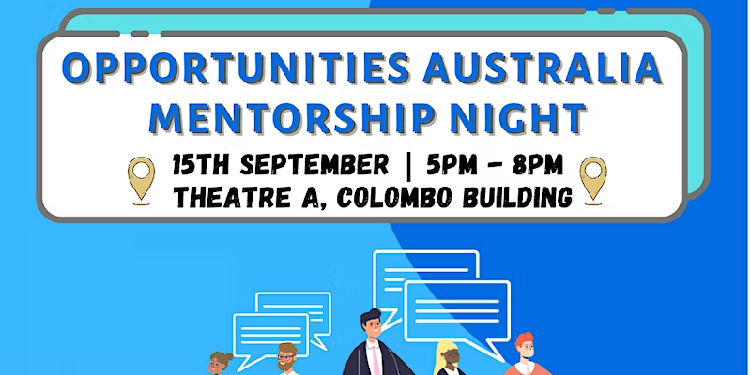

**PGC Coffee Catchups**

PGC Coffee Catchups are back in Term 3!

Join us for the next coffee catchup in the PGC Lounge – Tuesday 2-4pm Week 2 and Week 4

Want to meet other postgraduates in a casual and relaxed environment?  
Want free snacks and coffee on campus?

Come meet the PGC for a Coffee and Chat! Whether you need to kick back and unwind with good company or are stressed and need to voice your concerns about your course, swing by the PGC Lounge

Date and Time: Tuesdays 2pm to 4pm Week 2 and Week 4 and share them with the Postgraduate Council!  
Venue: PGC Lounge located on Level 2, Arc Precinct, Basser Steps

**External events**

**Experience Hong Kong – Saturday 27th August 2022**

Thank you for those who could make it to the Experience Hong Kong Celebration on Saturday 27th August 2022.

Hong Kong-Australia Business Association (HKABA) held a special one-off Hong Kong Experience on Saturday 27th August 2022.

2022 marks the 25th anniversary of the establishment of the Hong Kong Special Administrative Region (HKSAR) with the theme of "A New Era – Stability • Prosperity • Opportunity".

Fun, food and culture were featured throughout the day, with Sydneysiders getting the chance to experience the best of Hong Kong…. without ever setting a foot on a plane! "Experience Hong Kong" was held at the Hordern Pavilion, Moore Park, Sydney. The day was filled with the amazing sights, tastes and sounds of Hong Kong, from the ever-popular lion dance to Cantopop songs, plus a vast array of performances including martial arts, Taichi, Cantonese Opera, live band, children’s performances, and musicians showcasing traditional Chinese instruments.

More info on event website: <https://experiencehk.com.au/>

**Codess 2022 – Launch Your Career | 12th, 13th, and 14th September 2022**

Call out to all female and non-binary tertiary students exploring a career in tech!

Codess is a global Microsoft initiative to encourage female and non-binary students to explore a career in tech.

This year, the Microsoft Codess program has 3 jampacked days of exciting workshops where you can learn about the latest technology and have access to mentorship from leaders in Microsoft & industry!

No coding experience required – just bring a willingness to learn and curiosity!

Date and time: 12th, 13th and 14th September 2022

Venue: Online and In Person

Register now: aka.ms/Codess2022

To stay up to date with Codess 2022, join our LinkedIn group: [www.linkedin.com/groups/13763851/](http://www.linkedin.com/groups/13763851/)

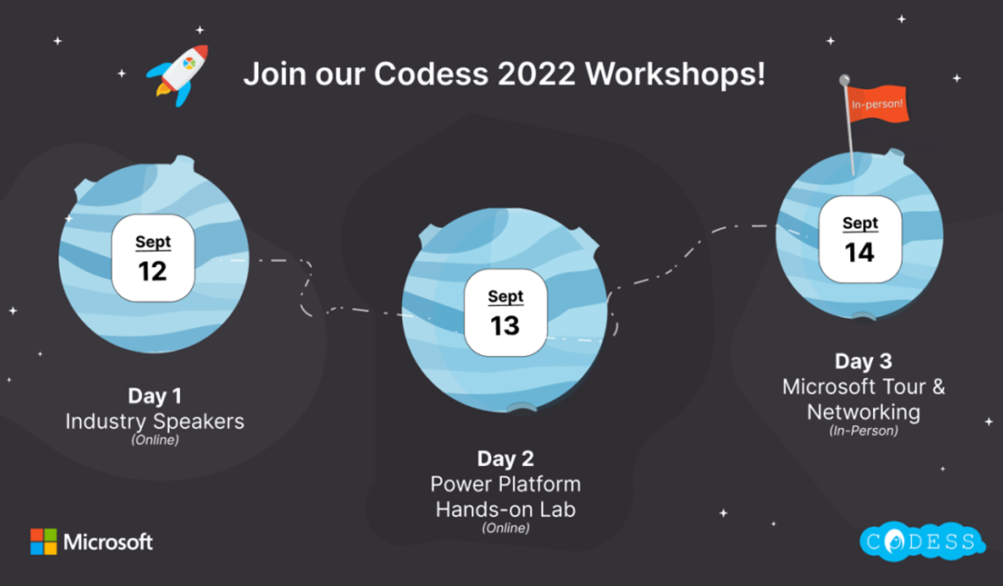

International Committee

**Updates**

A new international student at UNSW? Are you overwhelmed by your first week of going to university? We got your back! Find all services and programs tailored to your needs as an international student to elevate your experience at UNSW.

<https://unsw.sharepoint.com/:b:/s/PGC2022/ERzdOY7LU7pMoUm-IxifMYoB1yjqxvNmuTQfbBYWvCqRog?e=c45GdU>

*******************************

The International Office would like to thank those who joined us at the Postgraduate Pub last Friday! We had an amazing time with you all.

Keep an eye on our Facebook page, so that you don't miss our upcoming events!

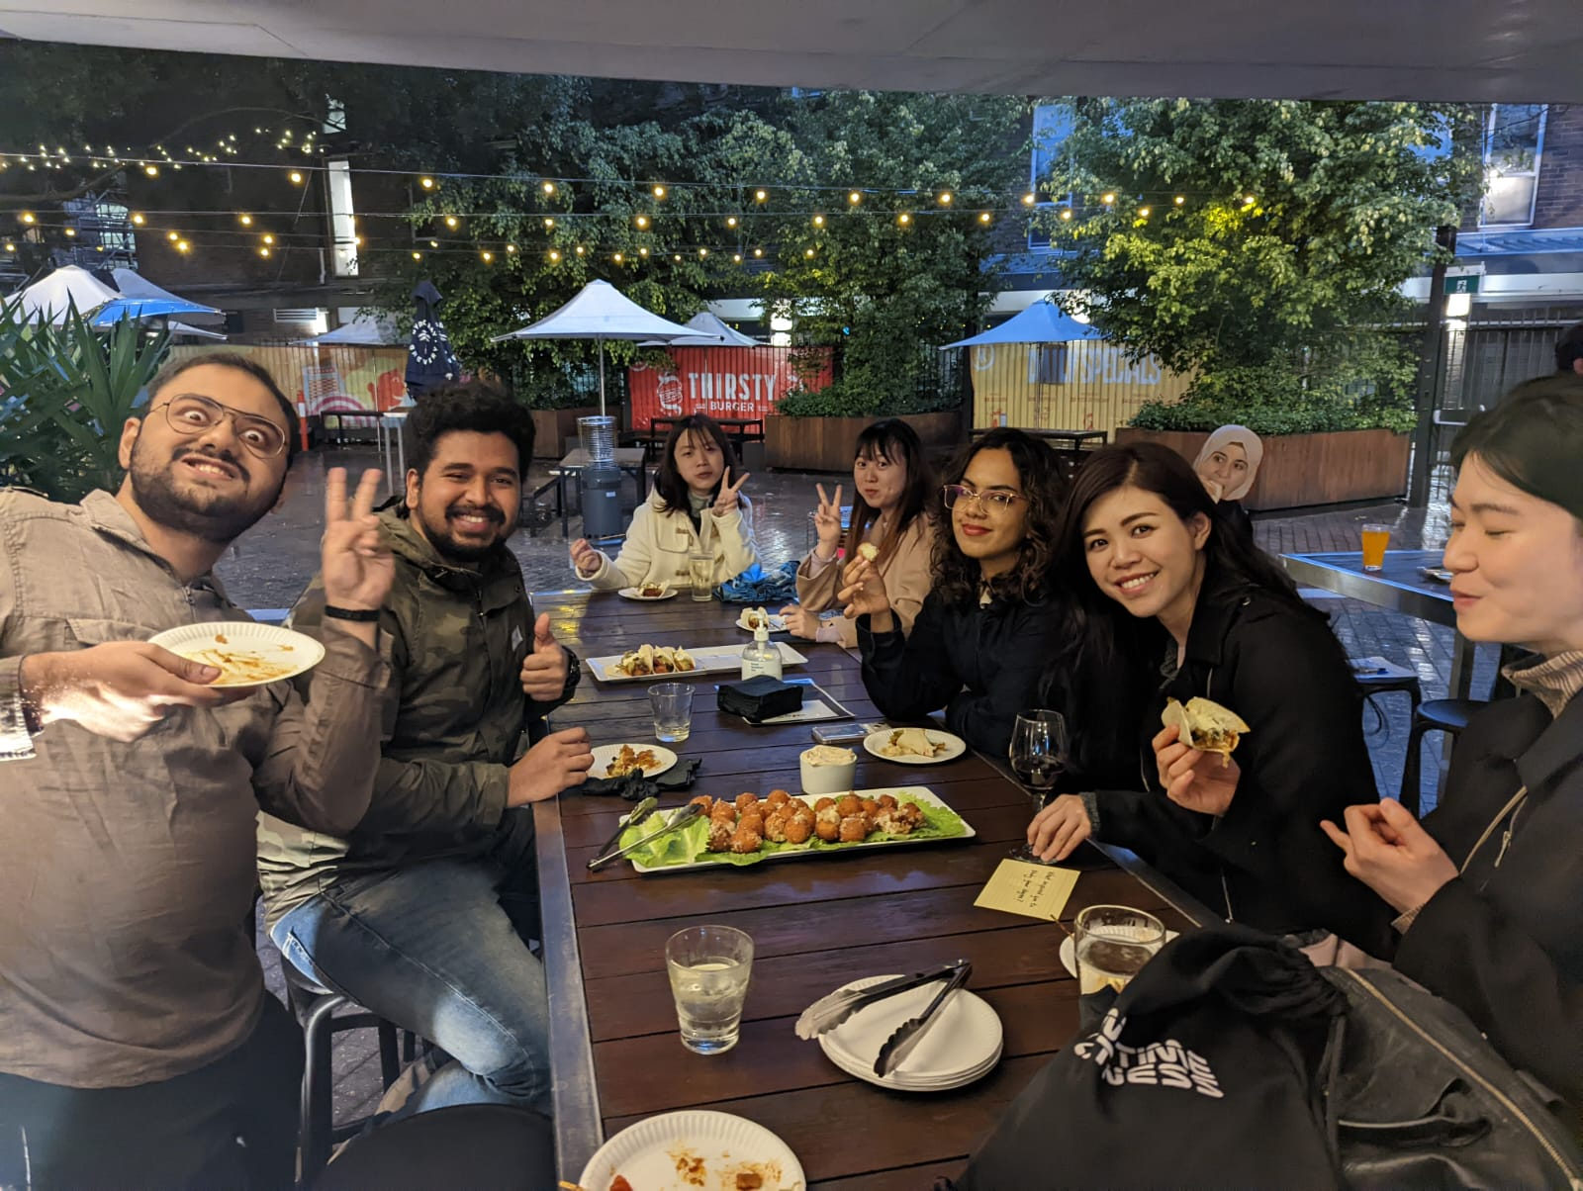

**Events**

**Job Search Strategies for International Students in Australia**

Are you approaching your job search strategically? Are you worried about securing a job as an international student?

Come join us virtually on 8th Sept. at 1pm to get some amazing insights from Katherine Pick, a career coach/career development consultant at UNSW Careers, and get your doubts cleared!

Registration link:

<https://www.eventbrite.com.au/e/399341389847>

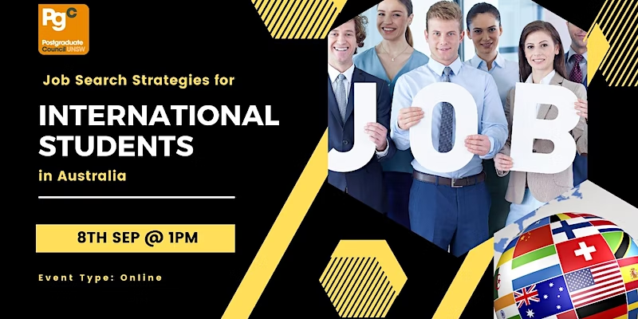

**International Food Competition**

Your culture, your recipe, your chance to win big

* Celebrating International Food Day
* Choose a recipe that represents your culture
* Submit your recipe by 30th Sept
* Literal cash up for grabs

Submission link:

<https://unsw.au1.qualtrics.com/jfe/form/SV_3ZNinqLHfktzspM>

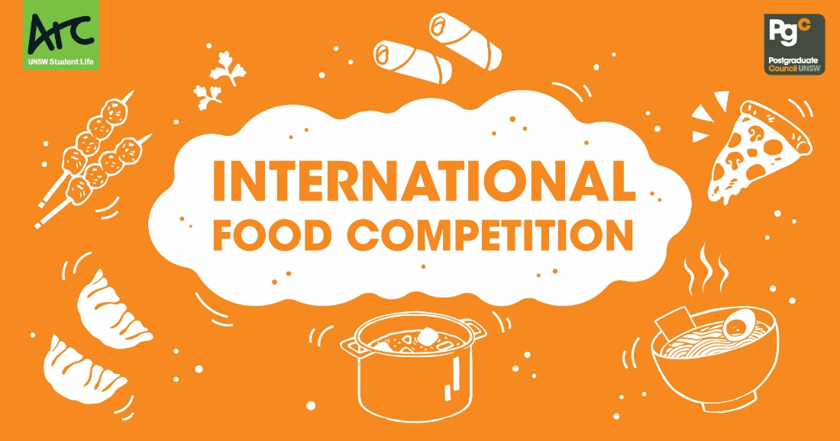

**External events**

myEnglish Week is a free program to help you build your language confidence and succeed at UNSW. Designed and delivered by expert English Language and Academic Skills teachers, the program is full of useful and fun sessions. You can join every day or choose sessions most useful for you. Some sessions will be in person and some will be delivered online.

Registration link:

<https://events.humanitix.com/myenglish-week-term-3>

Equity Committee

**Updates**

Feeling under-represented? We would love to hear from you to see how we can improve your Uni experience. Contact the PGC on any one of our social media outlets or emails.

**Events**

**Submissions for Tell Me Your Story 2022 open now!**

Do you have a story of a time you overcame adversity? The PGC is inviting you to tell us your story. All stories submitted will be published (anonymously, if you wish) in a beautiful e-book available freely both online and in print.

Writers of shortlisted stories will be invited to present their work as part of UNSW's Diversity Fest in late October.

💰 1st Prize $300

💸 2nd Prize $200

💵 3rd Prize $100

Story length: Around 300 words

Due date: 4th October

Submit your story using the link:

<https://docs.google.com/forms/d/e/1FAIpQLScJjj1K5Qm0YmCQ076T2NunDhDUx5xb0duPMps4rxgjPf4uqg/viewform>

**Burnout Seminar**

Have you ever felt Burnout? Burnout is a state of exhaustion that stems from excessive and prolonged stress (did anyone say Post-Grad studies?). It occurs when you feel overwhelmed, emotionally drained, and unable to meet constant demands.

Bridey Martin, who is an excellent Student Support Advisor at UNSW, will be leading a seminar on the **22nd September at 11am**. Here she will inform you of what Burnout is, how to prevent it, and what to do when you find yourself in a state of Burnout.

Sign up using the Eventbrite link:

<https://www.eventbrite.com.au/e/burnout-seminar-tickets-408323866677>

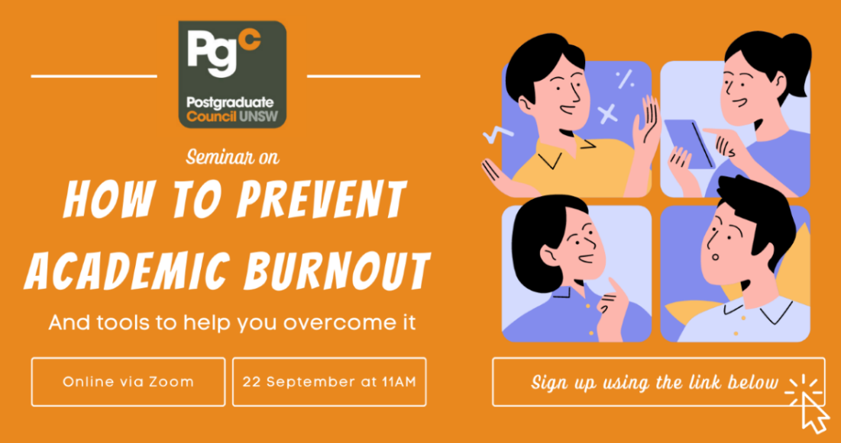

**External events**

Is your dating life a joke?

Does sexy talk just make you giggle?

Join us at Penny Lane for a night of laugher and good vibes. Hosted by comedian Brendan Hancock and featuring up and coming stand-up talent from Sydney’s Comedy scene sharing stories and commentary on their experiences with dating, relationships, sex and sexual health.

This event is brought to you by PGC and UNSW Health Promotions as part of SEXtember.

Get tickets using the link:

<https://events.humanitix.com/sextember-comedy-night>

